

**JAVA LAB EXERCISE 1**

*Name: Shivangi Agarwal*

*Class: 2 MCA B*

*Reg.no. 2447246*

Question:

Create class based on your domain with minimum 5 attributes.  
  
2. Use default constructor to display all your attributes initial value.   
3. Implement parameterized constructor that takes only three attributes values based on your domain attributes.  
4. Implement method, method overloading and constructor overloading concepts to do computational task based on your domain  
5. finally display your outcome.

CODE:

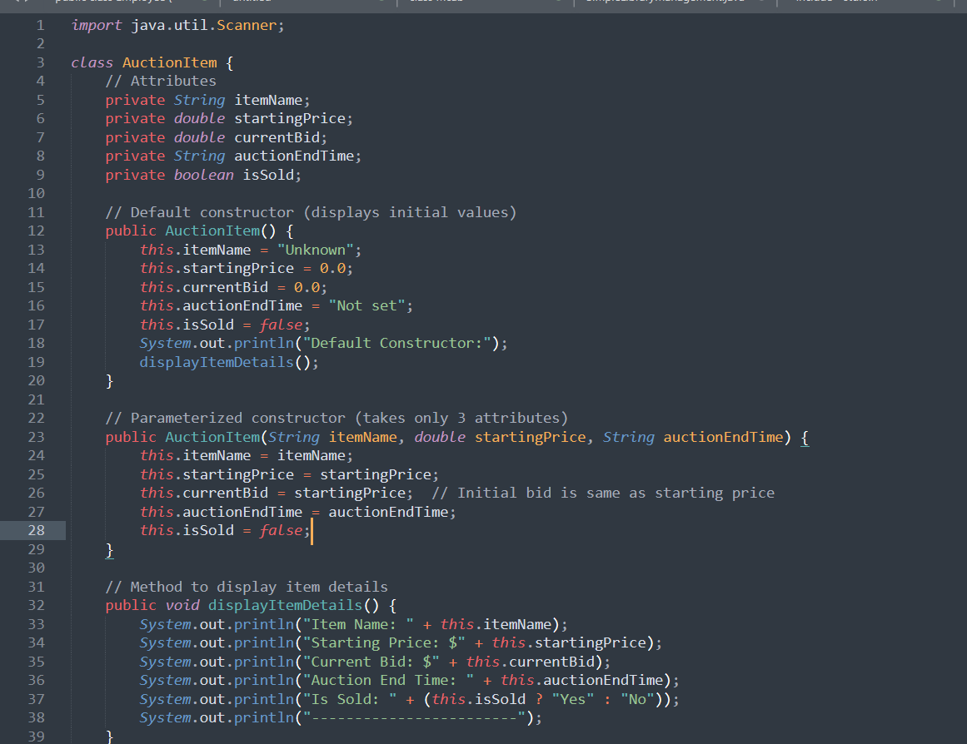

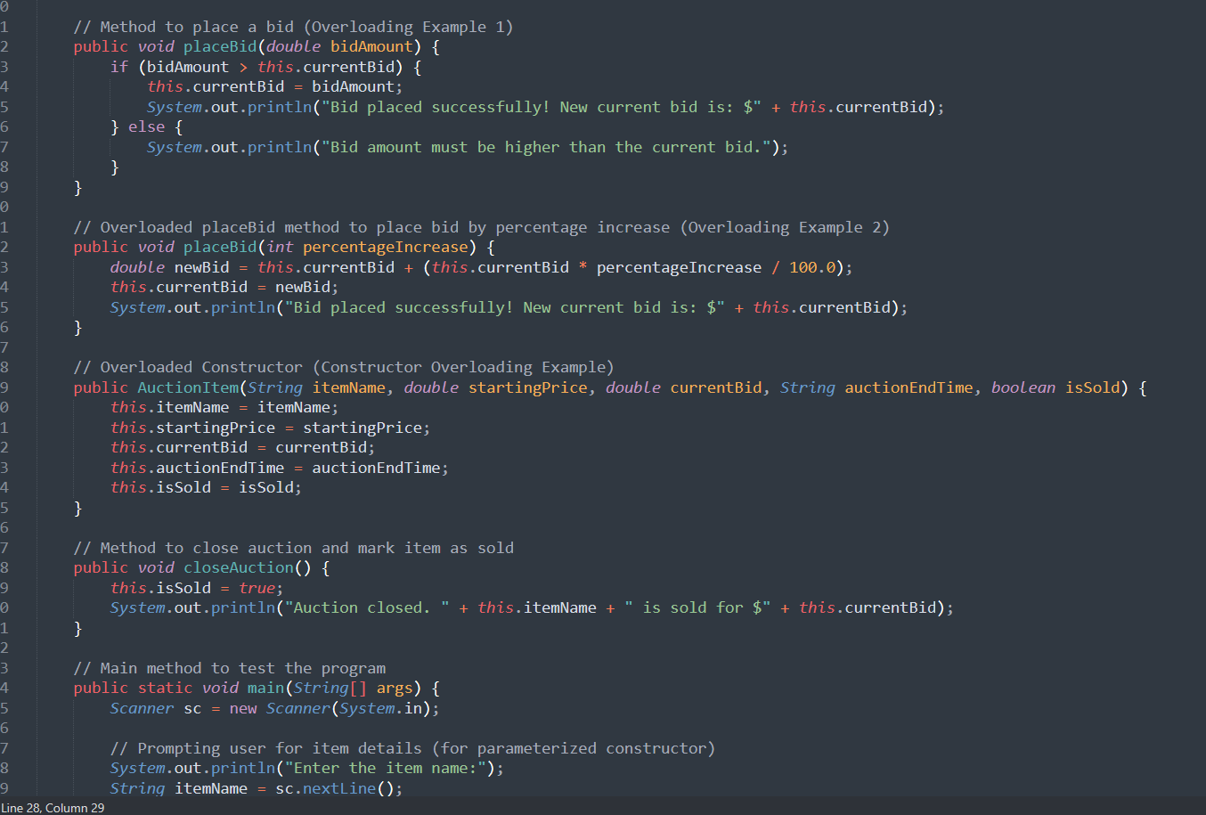

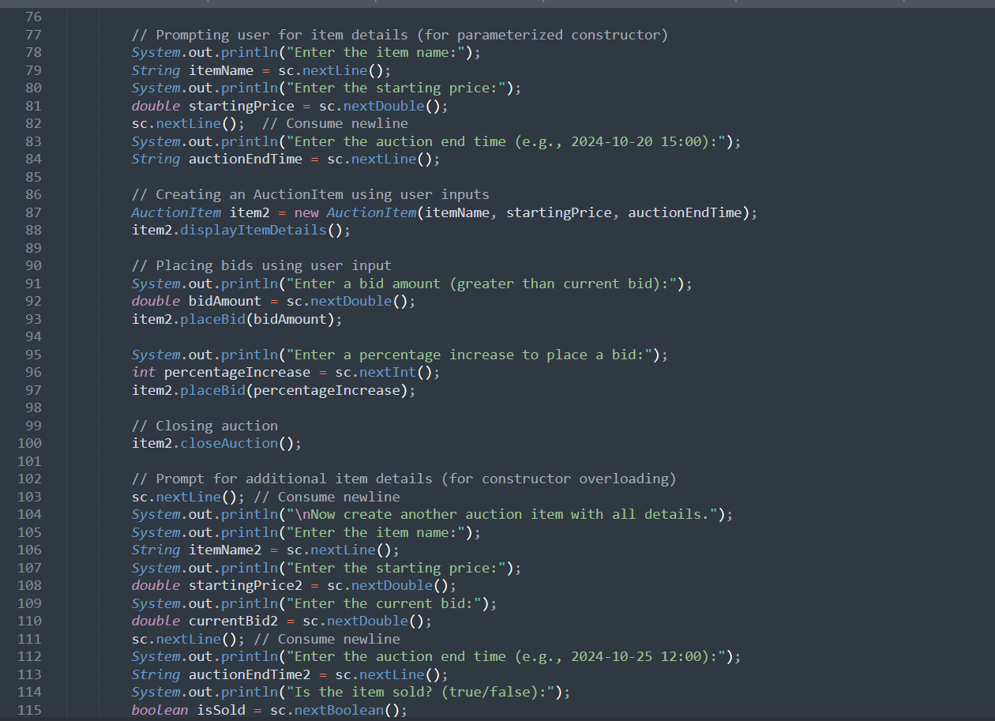

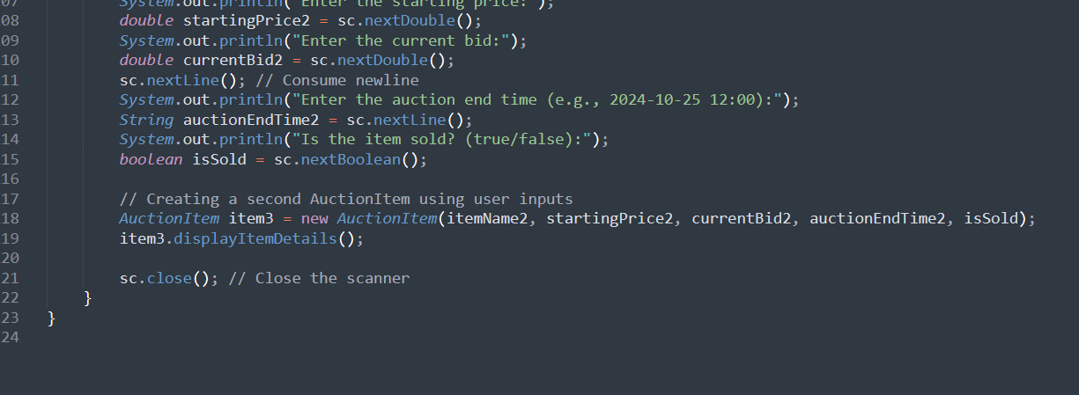

OUPUT:

